**Appendix VIII: Wamp installation**

**1) Install .exe**

Double click the setup file. If you experience the warning message in informing you the software lacks a valid security certificate, you can ignore this.

It is safe to run the software.

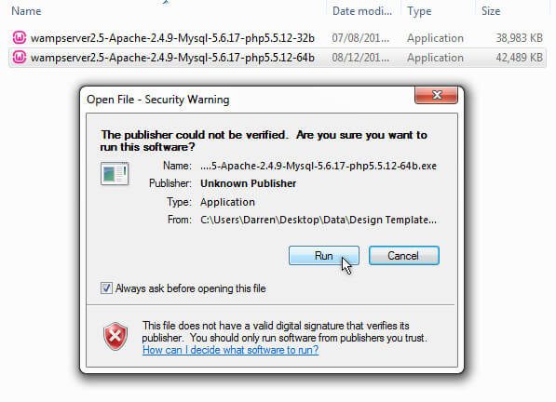

Next you’ll see the setup wizard welcome screen with details on the exact versions of what will be installed as part of WAMP. 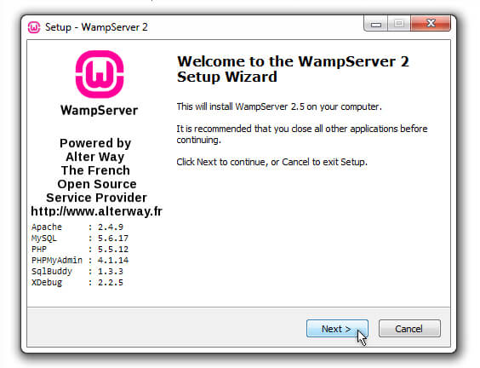

Follow the on-screen prompts and decide what location you’ll use for the software. By default it uses **C:\wamp\** but you can change this. 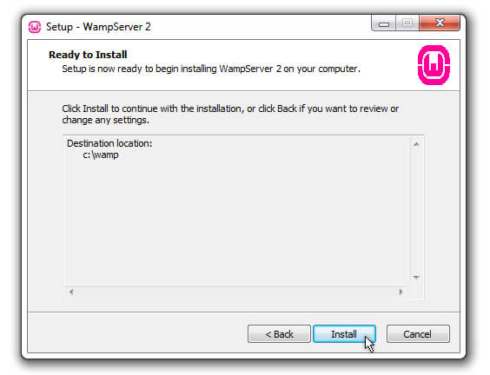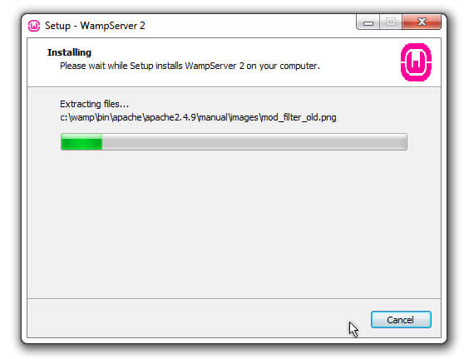

The software will install and then you’ll be prompted to choose what browser to use. By default it suggests Internet Explorer (bad idea!).

When prompted, navigate to your preferred browser.

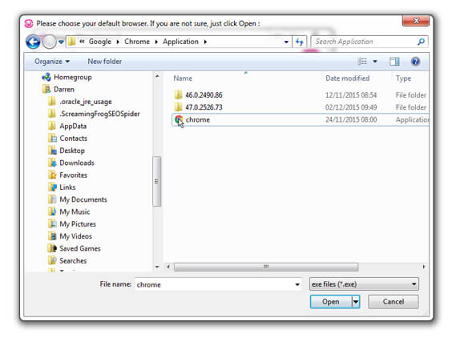

*Next, you’ll see a window asking for PHP mail settings. You can leave the defaults settings.*

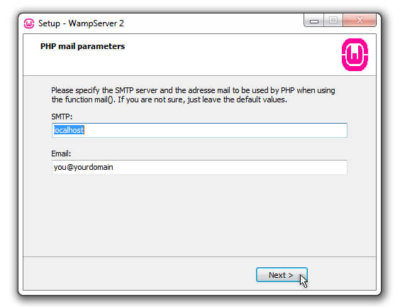

*You’ll see a message telling you the setup wizard has completed. Now you can click* finish. 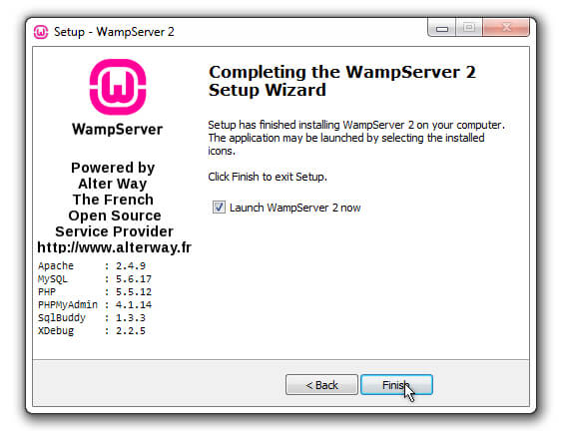

*Missing File Error During Installation?*

If you get a message telling you that **vcruntime140.dll** is missing, you might need **Microsoft Visual C++**, so download the latest version of that.

[You can the Visual C++ 2015 version here](https://www.microsoft.com/en-gb/download/details.aspx?id=48145). Uninstall WAMP fully first and restart your PC.

**2) Prevent Port 80 Skype Conflict**

Before you launch WAMP, I should point out there are conflict issues with [Skype](https://www.smallbizgeek.co.uk/tools/skype/).

Skype conflicts with WAMP because they both try to use port 80 by default.

If you are running Skype (the [classic 7.41 version](https://answers.microsoft.com/en-us/skype/forum/skype_windesk-skype_startms-skype_installms/skype-for-windows-desktop-v741-now-available-for/8507195c-826a-4da8-8cea-e8e3b0c06c06)), let me share a quick tip that will allow you to run it at the same time as WAMP without any problems.

Open Skype and click **Tools** > **Options** > **Advanced** > **Connection**

Uncheck the box titled **Use port 80 and 443 for additional incoming connections**

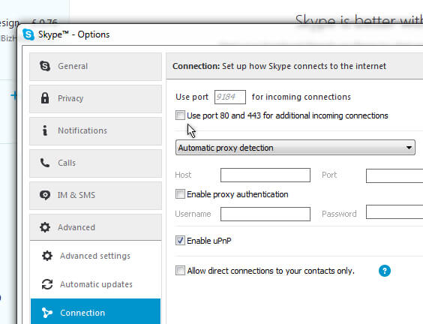

You might want to restart your computer at this point.

**3) Configuring WAMP**

You can launch the software by searching for WampServer in the Start Menu.

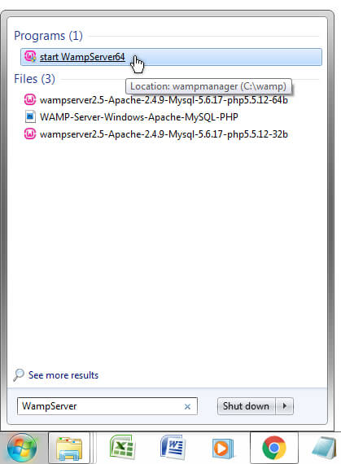

Click the icon and direct your attention to the Windows system tray on the lower far right side of your computer monitor.

You should see a green “W” icon. 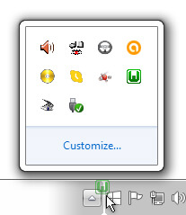

If you do not see the icon at all, it might be hidden in the mini flyout menu denoted by the small arrow.

You can drag and reposition the “W” icon in your system tray.

When you launch the software, the icon should turn green, but often it will not.

Sometimes it will jump straight to green, other times it will slowly change to green through red and amber. Red is bad, amber is bad, green is good.

But what if your icon is stuck on red or amber?

Red or Amber Icon

A red icon means something is blocking port 80. Try the Skype tip I mentioned. If you’re running a firewall or antivirus software, try disabling it.

An amber icon colour means the Apache services have not started.

You could try the **Restart All Services** option. This is the first thing I try when I need to refresh everything.

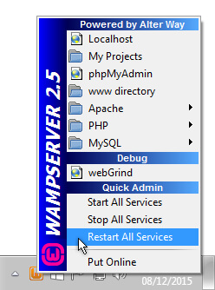

If this does not work, try **Apache** > **Service** > **Start/Resume Service**

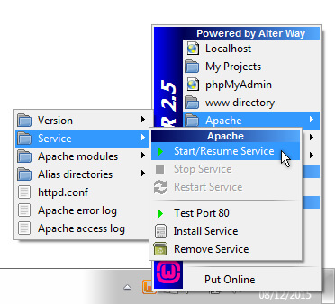

Still no change?

Here’s another suggestion: change the port number used by WAMP in the **httpd.conf** file.

Click **Apache** > **Services** > **httpd.conf**

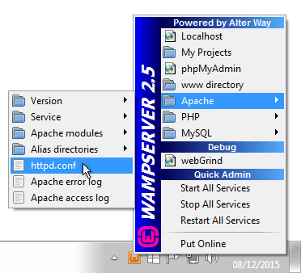

Search **httpd.conf** using CTRL & F.

Locate the three occurences of **:80** and change them to **:8080**

This is what you’re looking for:

Listen 0.0.0.0:80

Listen [::0]:80

ServerName localhost:80

If you do change the port number in **httpd.conf** you will have to manually add **:8080** to all your urls including **localhost/**

Your development server homepage will be something like **localhost:8080/**

#### Why is WAMP “Offline?”

If you’re using WAMP “out-of-the-box” you will be using it “offline”. Don’t let this confuse you.

This is the default operating mode and is no way indicative of an error.

WAMP server OFFLINE

**www Directory**

The www directory is installed to **C:\wamp\www\** by default. You can access this quickly via the WAMP menu in the system tray.

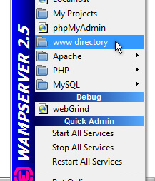

Create a new folder in the **www directory** and call it anything you want.

For the purposes of this guide I’m calling the new folder “test”.

### 5) Accessing localhost

The URL **localhost/** is the address of your offline testing environment. When your site is uploaded to your host you change all occurrences **localhost/** to your domain name.

To open up the localhost homepage, click the green “W” icon in your system tray and choose Localhost.

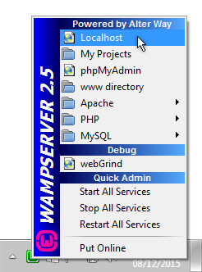

You will be presented with the localhost homepage in a new browser window.

It looks something like the following screenshot. Notice the “test” folder has appeared here, under**Your Projects**:

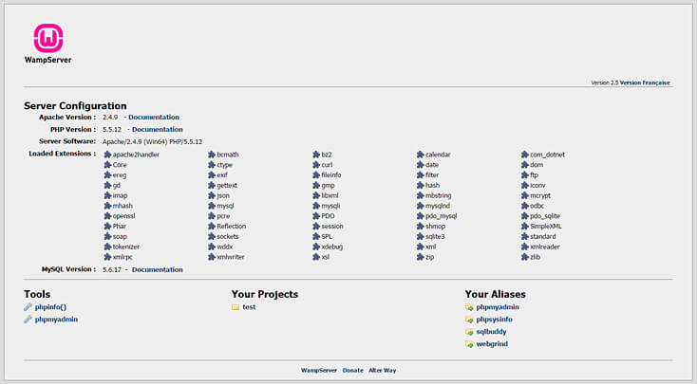

#### Setup Database

Let’s get started by creating the database inside WAMP using phpMyAdmin.

Visit localhost and click the blue phpmyadmin link. Alternatively, use the menu from the system tray icon to access phpmyadmin.

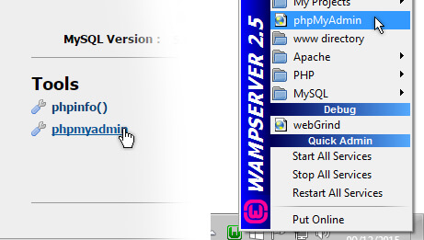

The phpMyAdmin interface will open. Click the **Databases** tab.

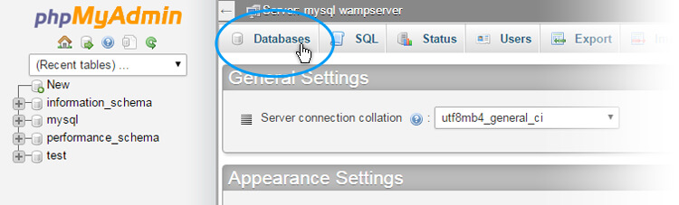

Now create a database, giving it a name of your choosing. You can call it anything you want.

If you use uppercase characters, they’ll automatically become lowercase when the database is created.

